**KAMPALA PARENTS’ SCHOOL 2004**

**END OF TERM TWO 2023**

**READING**

**PRIMARY TWO**

DURATION: 2HRS

NAME: ...................................................................................................

STREAM: ...............................................................…………….……………

**1. Listen and write**

a) __________________________ b)_________________________

c) ________________________________________________________

**2. Use all the letters in the given word to write a new word**

a) eat____________________ b) hate____________________

c) mela_____________________

**3. Write a word with the given sound**

a) ou__________________________ b) ss:_______________________

c) sh:__________________________ d) ch______________________

1. **Write small words from these words.**

|  |  |
| --- | --- |
| 1. stable_________________ 2. hutch_________________ | 1. wasp_________________ 2. plant _________________ |

(c) turkey_________________

**5. Identify and write three words of sound “nt” correct words from the puzzle below**

|  |  |  |  |  |  |
| --- | --- | --- | --- | --- | --- |
| p | e | s | t | l | e |
| l | m | a | l | e | g |
| a | n | t | a | a | g |
| n |  | e | s | f | s |
| t | e | n | t | s |  |

a) ___________________ b)________________ c)______________

**Any other correct word without sound “nt”**

d) __________________________

**6. Read and draw pictures**

a) This is a flat house

b) The boy is sweeping on the floor

c) The flower is in the pot.

d) The bird is flying over the tree

e) Uganda flag.

**7. Read the rhyme bellow and answer the questions that follow in full sentences.**

The little mouse in the house.

It runs around the room

Squeaking loudly out and about.

Eating my yummy snacks

Biting Dad’s trousers and,

Mummy’s blouse too.

Questions.

a) What is the thyme about?

________________________________________________________

b) How many lines does the rhyme have?

________________________________________________________

c) Where does the mouse run to?

________________________________________________________

d) What sound is made by the mouse?

________________________________________________________

e) Mention any two things the mouse bites

a) ___________________________ b)_____________________

f) Give another word to mean yummy.

________________________________________________________

**8. Write the word correctly**

a) aglss____________________________ b) ketsco_______________

c) ldchi__________________________ d) narygra_____________

10. Read the story and answer the questions that follow.

Last holiday, Tom, Zaria and Rose visited aunt Dorah. Aunt Dorah lives in Busega. She was very happy to see them. She gave them milk tea and bread. After tea, they started playing different games. Tom played football, Zaria played hide and seek and Rose played netball.

Questions

1. Where does aunt Dora live?

____________________________________________________________

1. How many children visited aunt Dorah?

____________________________________________________________

1. Who played football?

____________________________________________________________

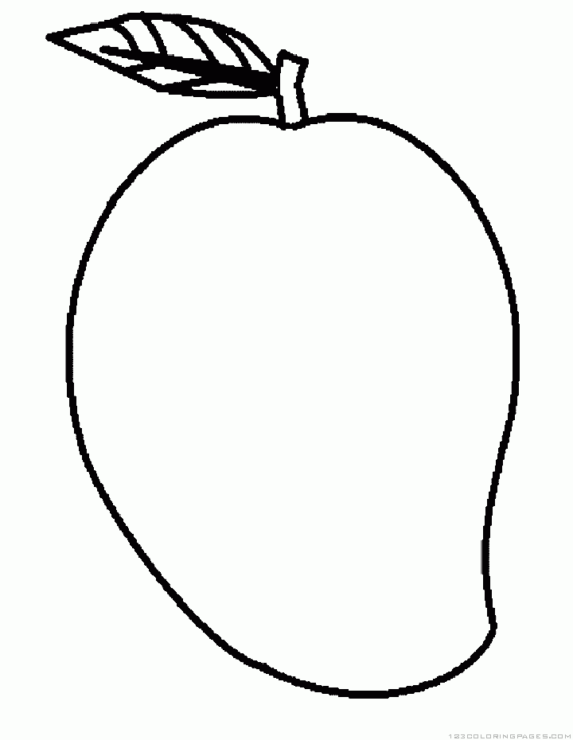**9. Use the pictures to fill in the puzzle.**

**S**

**N**

**O**

**E**

**M**

**B**

**N**

**A**

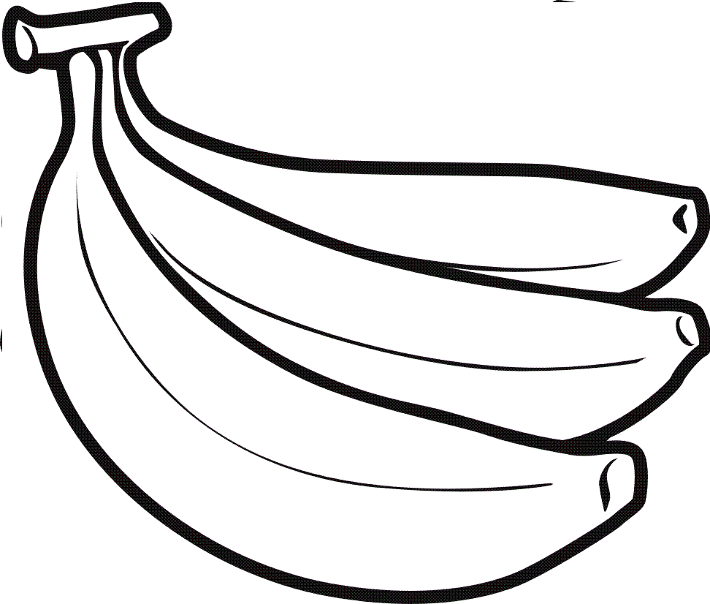

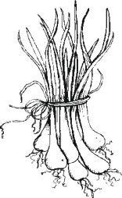

**12. Read and draw**

|  |  |
| --- | --- |
|  |  |
| **There are three cats.** | **They are skipping a rope.** |
|  |  |
| **Mother is cooking food.** | **This is a Bible.** |